**Exercise 1: Control Structures**

**Scenario 1:** The bank wants to apply a discount to loan interest rates for customers above 60 years old.

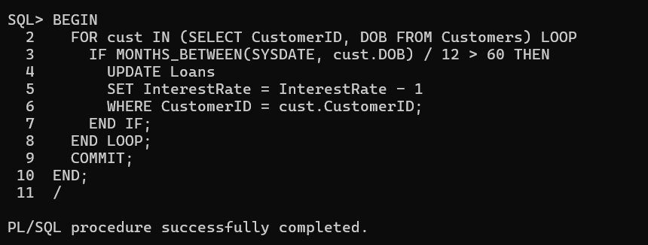

**Scenario 2:** A customer can be promoted to VIP status based on their balance.

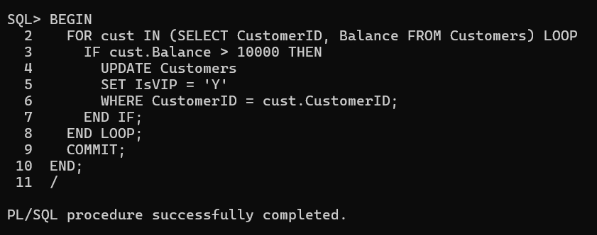

**Scenario 3:** The bank wants to send reminders to customers whose loans are due within the next 30 days.

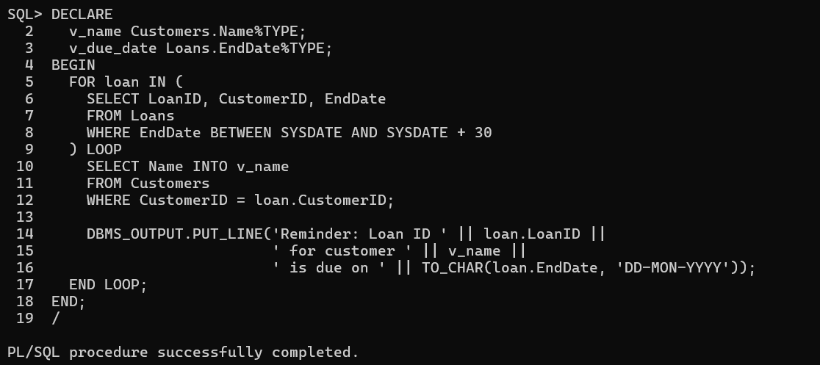

**Exercise 2: Error Handling**

**Scenario 1:** Handle exceptions during fund transfers between accounts.

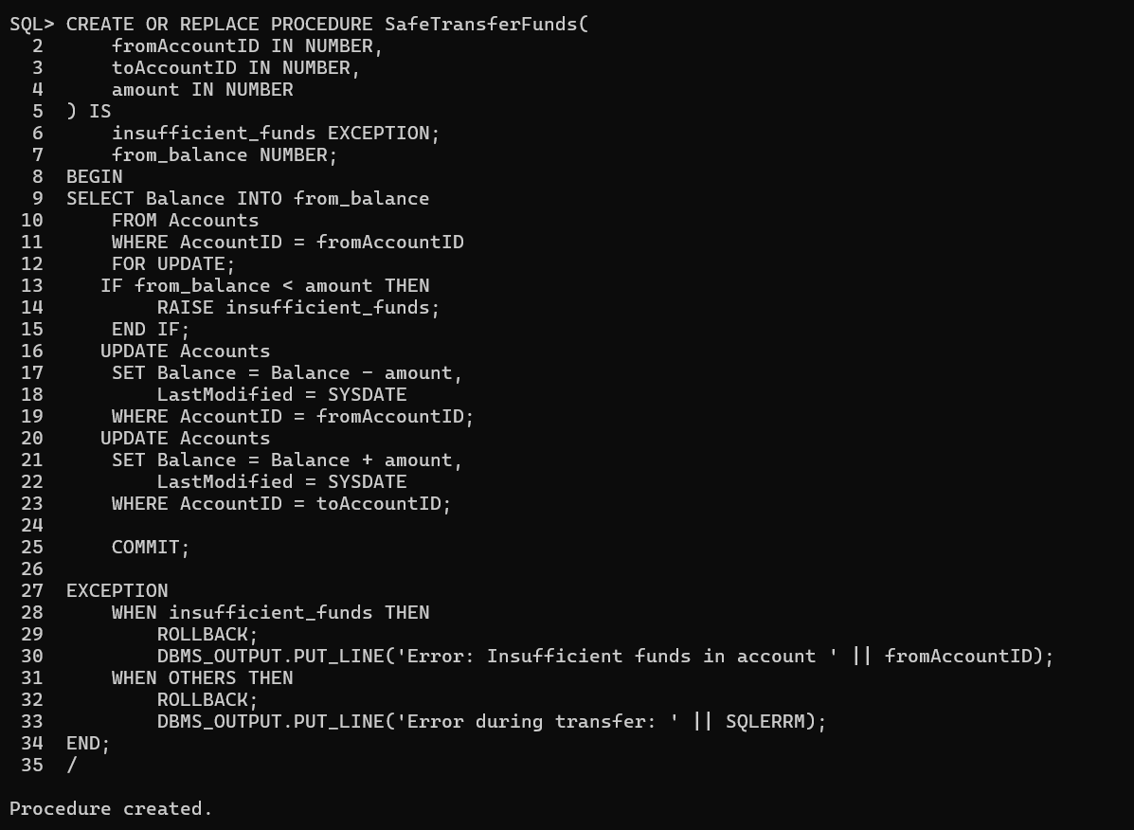

**Scenario 2:** Manage errors when updating employee salaries.

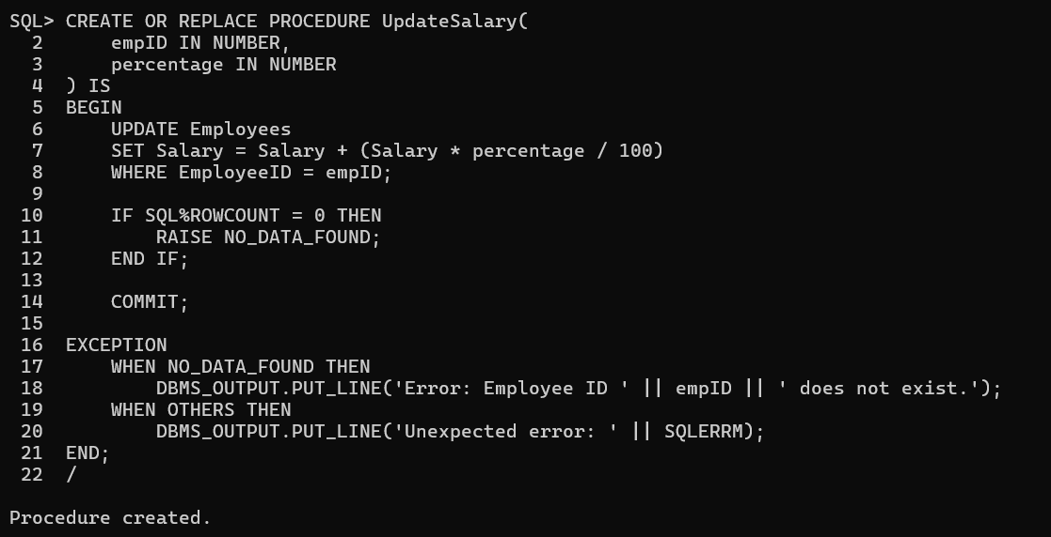

**Scenario 3:** Ensure data integrity when adding a new customer.

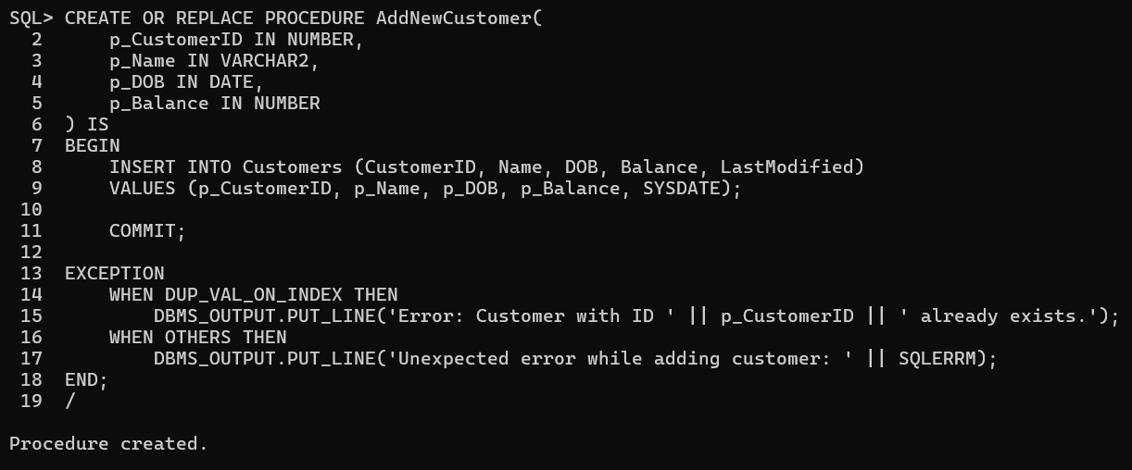

**Exercise 3: Stored Procedures**

**Scenario 1:** The bank needs to process monthly interest for all savings accounts.

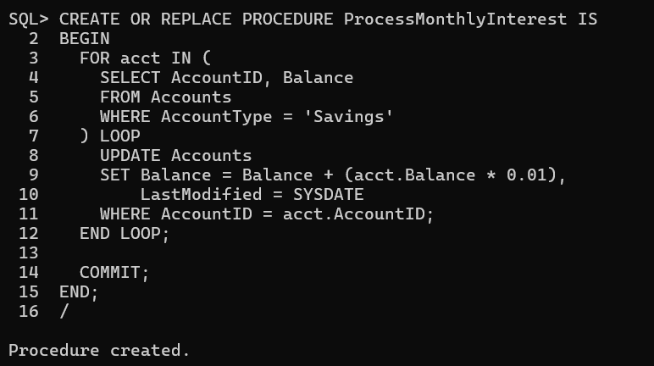

**Scenario 2:** The bank wants to implement a bonus scheme for employees based on their performance.

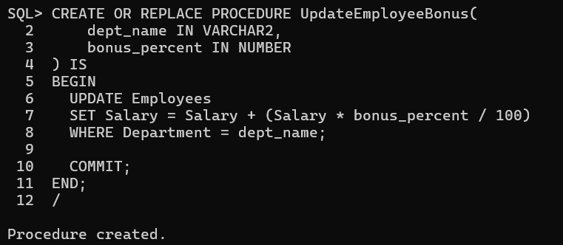

**Scenario 3:** Customers should be able to transfer funds between their accounts.

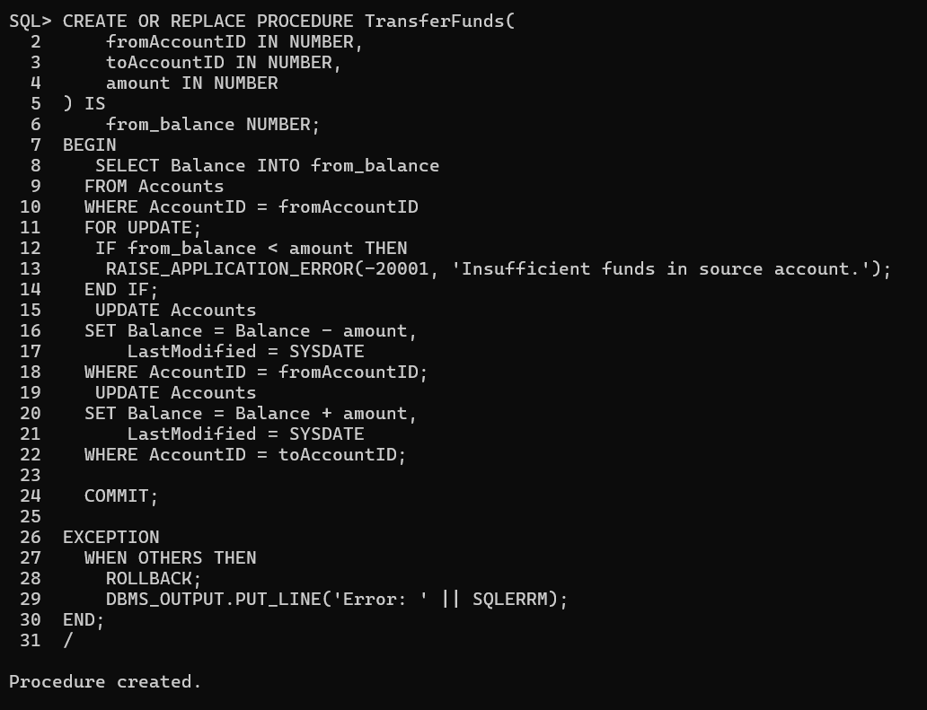

**Exercise 4: Functions**

**Scenario 1:** Calculate the age of customers for eligibility checks.

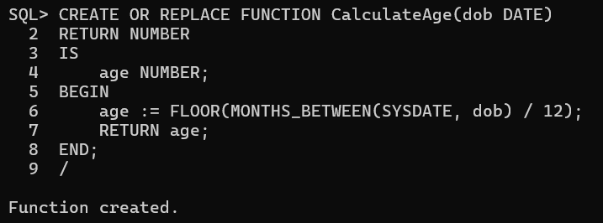

**Scenario 2:** The bank needs to compute the monthly installment for a loan.

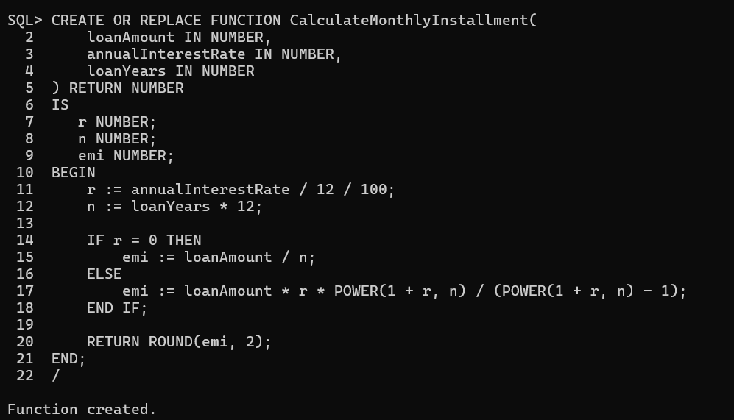

**Scenario 3:** Check if a customer has sufficient balance before making a transaction.

